|  |  |
| --- | --- |
| Ship: |  |
| Date: |  |
| **WASTE MANAGEMENT ORGANIZATION**  **&**  **PROCESSING EQUIPMENT** | |

**This form is to be used in conjunction with Garbage Management Procedures. It supplements the common garbage management requirements applicable to managed ships by outlining ship specific procedures and the above procedures and this form constitute the Marpol V required Garbage Management Plan (and in accordance with IMO res. MEPC.220(63) “2012 Guidelines for the Development of Garbage Management Plans” and IMO res. MEPC.295(71) “2017 Guidelines for the Implementation of Marpol Annex V”)**

**This form has FIVE Sections which should be filled with the ship specific details by the onboard management, kept updated and a copy sent to the Marine Superintendent/DPA for review, approval and logging it into the S/E/MS (Safety/Environmental Management System)**

**SECTION 1**

1. **Incineration**
   1. Ash and clinkers from shipboard incinerators should be considered as operational waste and, therefore, as garbage that is not eligible for discharge into the sea
   2. Shipboard incineration should not be undertaken when the ship is in port or at offshore terminal. Some ports may have domestic laws that specify additional air emission restrictions, particularly those near high population areas. The use of a shipboard incinerator may require permission from the port authority concerned
   3. Each operator of the onboard garbage incinerator shall be trained and familiar in the use of the equipment and the types of garbage that can be destroyed in the incinerator.
   4. Marine incinerators are predominantly designed for intermittent operation, hand-fired and fed by hand. The ash or vapour may be hazardous. Incinerator ash may be subject to local quarantine, sanitary or health requirements. Advice should be sought from local authorities regarding requirements that are in addition to MARPOL.
   5. The incineration of garbage that contains a large amount of plastic involves very specific incinerator settings such as higher oxygen injection and higher temperatures (850 to 1,200°C). If these special conditions are not met, depending on the type of plastic and conditions of combustion, some toxic gases can be generated in the exhaust stream, including vaporized hydrochloric (HCl) and hydrocyanic (HCN) acids. These and other intermediary products of combustion of waste containing plastics are toxic to humans and marine life
   6. A table giving guidelines on incineration options for shipboard-generated garbage may be found in section 3.
2. **Comminuters (or grinders)**
   1. Comminuters grind food wastes to a particle size capable of passing through a screen with openings no larger than 25 mm (1 inch).
   2. When operating inside a special area, regulation 6 of MARPOL Annex V requires all food wastes to be comminuted or ground prior to discharge in to the sea. All discharges are to be as far as practicable and not less than 12 nautical miles from the nearest land or ice-shelf.
3. **Compactors (incl. Glass/Tin Crushers)**
   1. If grinding machines are used prior to compaction, the compaction ratio can be increased and the storage space decreased.
   2. Compactors have options including sanitizing, deodorizing, adjustable compaction ratios, bagging in plastic or paper, boxing in cardboard (with or without plastic or wax paper lining), baling, etc.
   3. Compacted materials should be stored appropriately. While metal and plastic bales can get wet, paper and cardboard bales should be kept dry.
   4. A table giving shipboard generated garbage compaction options may be found in section 4.

**SECTION 2**

**GARBAGE PROCESSING EQUIPMENT**

|  |  |  |  |  |
| --- | --- | --- | --- | --- |
|  | *INCINERATOR* | *COMPACTOR* | *COMMINUTER* | *CRUSHER* |
| MAKE: |  |  |  |  |
| LOCATION: |  |  |  |  |
| SOLID WASTE LOADING DETAILS:  Capacity per charge |  |  |  |  |
| DESIGN TEMP |  |  |  |  |

**SECTION 3**

**INCINERATION OPTIONS FOR SHIPBOARD-GENERATED GARBAGE**

|  |  |  |  |  |  |  |
| --- | --- | --- | --- | --- | --- | --- |
| *Typical examples* | *Special handling by vessel personnel before incineration* | ***Incineration Characteristics*** | | | | *On-board storage space* |
| *Combustibility* | *Reduction of volume* | *Residual* | *Exhaust* |
| Paper packaging, food and beverage containers | Minor – easy to feed into hopper | High | Over 95% | Powder ash | Possibly smoky and not hazardous | Minimum |
| Fibre and paper board | Minor – reduce material to size for feed; minimum manual labour | High | Over 95% | Powder ash | Possibly smoky and not hazardous | Minimum |
| Plastic packaging, food and beverage containers, etc… | Minor – easy to feed into hopper | High | Over 95% | Powder ash | Possibly smoky and hazardous based on incinerator design | Minimum |
| Plastic sheeting, netting, rope and bulk material | Moderate manual labour time for size reduction | High | Over 95% | Powder ash | Possibly smoky and hazardous based on incinerator design | Minimum |
| Rubber hoses and bulk pieces | Major manual labour time for size reduction | High | Over 95% | Powder ash | Possibly smoky and hazardous based on incinerator design | Minimum |
| Metal food and beverage containers, etc… | Minor – easy to feed into hopper | Low | Less 10% | Slag | Possibly smoky and not hazardous | Moderate |
| Metal cargo, bulky containers, thick metal items | Major manual labour time for size reduction (not easily incinerated) | Very low | Less 5% | Large metal fragments and slag | Possibly smoky and not hazardous | Maximum |
| Glass food and beverage containers, etc… | Minor – easy to feed into hopper | Low | Less 10% | Slag | Possibly smoky and not hazardous | Moderate |
| Wood, cargo containers and large wood scraps | Moderate manual labour time for size reduction | High | Over 95% | Powder ash | Possibly smoky and not hazardous | Minimum |

**SECTION 4**

**COMPACTION OPTIONS FOR SHIPBOARD-GENERATED GARBAGE**

|  |  |  |  |  |  |
| --- | --- | --- | --- | --- | --- |
| *Typical examples* | *Special handling by vessel personnel before compaction* | *Compaction characteristics* | | | *Onboard storage space* |
| *Rate of alteration* | *Retains compacted form* | *Density of compacted form* |
| Metal, food and beverage containers, glass, small wood pieces | None | Very rapid | Almost 100% | High | Minimum |
| Comminuted plastics, fibre and paper board | Minor – reduce material to size for feed, minimal manual labour | Rapid | Approximately 80% | Medium | Minimum |
| Small metal drums, uncomminuted cargo packing, large pieces of wood | Moderate –longer manual labour time required to size material for feed | Slow | Approximately 50% | Relatively low | Moderate |
| Uncomminuted plastics | Major- very long manual labour time to size material for feed; usually impractical | Very slow | Less than 10% | Very slow | Maximum |
| Bulky metal cargo containers, thick metal items | Impractical for shipboard compaction; not feasible | Not applicable | Not applicable | Not applicable | Maximum |

**SECTION 5**

**GARBAGE MANAGEMENT PLAN SHIP SPECIFIC PROCEDURES**

Please be guided by Appendix 1 Options for shipboard handling and discharge of garbage

To achieve cost-effective and environmentally sound results the following combination of complementary techniques to manage garbage will be used:

* reduction at source
* reusing or recycling
* onboard processing (treatment)
* discharge into the sea (in those limited situations where it is permitted)
* discharge to a port reception facility

**5.1 Designated person in charge of carrying out the Garbage Management Plan (GMP) onboard this ship is:**

(typically this should be the Staff Captain or Chief Officer or alternatively delegated to another designated officer such as an Environmental Officer)

**Assisted by:**

*(this designated person is to be assisted by departmental staff to ensure that the minimization, collection, separation and processing of garbage is efficient in all areas of the ship and that all procedures aboard are carried out in accordance with the GMP.)*

**5.2 Procedures for collecting garbage:**

**.1 Identify suitable receptacles for collection and separation:**

|  |  |
| --- | --- |
| **Collection:** | **Separation:** |
|  |  |
|  |  |
|  |  |
|  |  |
|  |  |
|  |  |
|  |  |
|  |  |

*(Separation is part of the collection process and it may take place at the source or at a separate designated station – please identify)*

**.2 Identify locations of receptacles, collection and separation stations:**

|  |  |  |
| --- | --- | --- |
| **Location:** | **Collection:** | **Separation Station:** |
|  |  |  |
|  |  |  |
|  |  |  |
|  |  |  |
|  |  |  |
|  |  |  |
|  |  |  |
|  |  |  |

**.3 Describe the process of how garbage is transported from the source of generation to the collection and separation stations**

**.4 Describe how garbage will be handled between primary collection and separation stations and other handling methods commensurate with the following:**

**.1needs of reception facilities, taking into account possible local recycling arrangements:**

**.2 on-board processing and potential reuse of garbage onboard the ship:**

**.3 storage:**

**.4 discharge into the sea in those limited situations where it is permitted:**

**.5 Describe the training or education programmes to facilitate collection of garbage and sorting of reusable or recyclable material:**

*(As per the Training Induction package onboard, the Safety Familiarization Training, the VOD box training materials in use and any ship specific training information)*

**5.3 Procedures for processing garbage:**

**.1 identify personnel responsible for the operation of the processing equipment listed under Section 2:**

**.2 identify the categories of garbage that are to be processed by each of the devices listed under Section 2, having in mind the guidance given under Sections 1, 3 and 4.**

**.3 describe how material that can be reused or recycled is to be handled between primary processing stations and the storage or transfer stations**

**.4 describe processing procedures used for the following:**

**.1 needs of reception facilities, taking into account possible local recycling arrangements**

**.2 storage:**

**.3 discharge into the sea in those limited situations where it is permitted:**

**.5 describe the training or education programmes to facilitate the processing of garbage and reuse or recycling of material:**

**.6 identify standing operating procedures or orders for the operation and maintenance of the equipment used to managed garbage (this may be done by reference to documents / manuals available onboard:**

**5.4 Procedures for storing garbage or reusable or recyclable material:**

**.1 identify the location, the intended use, and the capacities of available storage stations for each category of garbage or reusable or recyclable material**

**Category A, Plastic** (solid material which contains as an essential ingredient one or more high molecular mass polymers and which is formed (shaped) during either manufacture of the polymer or the fabrication into a finished product by heat and/or pressure. Plastics have material properties ranging from hard and brittle to soft and elastic. "All plastics" means all garbage that consists of or includes plastic in any form, including synthetic ropes, synthetic fishing nets, plastic garbage bags and incinerator ashes from plastic products)**:**

|  |  |  |
| --- | --- | --- |
| **Location:** | **Intended Use:** | **Capacity:** |
|  |  |  |
|  |  |  |
|  |  |  |
|  |  |  |
|  |  |  |
|  |  |  |
|  |  |  |
|  |  |  |

**Category B, Food Wastes** (any spoiled or unspoiled food substances and includes fruits, vegetables, dairy products, poultry, meat products and food scraps generated aboard ship)**:**

|  |  |  |
| --- | --- | --- |
| **Location:** | **Intended Use:** | **Capacity:** |
|  |  |  |
|  |  |  |
|  |  |  |
|  |  |  |
|  |  |  |
|  |  |  |
|  |  |  |
|  |  |  |

**Category C, Domestic Waste (**e.g. paper products, rags, glass, metal, bottles, crockery, etc; all types of wastes not covered by other Marpol Annexes that are generated in the accommodation spaces on board the ship; does not include grey water**):**

|  |  |  |
| --- | --- | --- |
| **Location:** | **Intended Use:** | **Capacity:** |
|  |  |  |
|  |  |  |
|  |  |  |
|  |  |  |
|  |  |  |
|  |  |  |
|  |  |  |
|  |  |  |

**Category D, Cooking Oil** (any type of edible oil or animal fat used or intended to be used for the preparation or cooking of food, but does not include the food itself that is prepared using these oils)**:**

|  |  |  |
| --- | --- | --- |
| **Location:** | **Intended Use:** | **Capacity:** |
|  |  |  |
|  |  |  |
|  |  |  |
|  |  |  |
|  |  |  |
|  |  |  |
|  |  |  |
|  |  |  |

**Category E, Incinerator Ashes** (ash and clinkers resulting from shipboard incinerators used for the incineration of garbage)**:**

|  |  |  |
| --- | --- | --- |
| **Location:** | **Intended Use:** | **Capacity:** |
|  |  |  |
|  |  |  |
|  |  |  |
|  |  |  |
|  |  |  |
|  |  |  |
|  |  |  |
|  |  |  |

**Category F, Operational Wastes** (all solid wastes (including slurries) not covered by other Marpol Annexes that are collected on board during normal maintenance or operations of a ship, or used for cargo stowage and handling. Operational wastes also includes cleaning agents and additives contained in cargo hold and external wash water. Operational wastes does not include grey water, bilge water, or other similar discharges essential to the operation of a ship)**:**

|  |  |  |
| --- | --- | --- |
| **Location:** | **Intended Use:** | **Capacity:** |
|  |  |  |
|  |  |  |
|  |  |  |
|  |  |  |
|  |  |  |
|  |  |  |
|  |  |  |
|  |  |  |

**Category G, Animal Carcasses** (the bodies of any animals [that are carried on board as cargo] and that die or are euthanized during the voyage)**:**

|  |  |  |
| --- | --- | --- |
| **Location:** | **Intended Use:** | **Capacity:** |
|  |  |  |
|  |  |  |
|  |  |  |
|  |  |  |
|  |  |  |
|  |  |  |
|  |  |  |
|  |  |  |

**Category I, E-Waste** (electrical and electronic equipment used for the normal operation of the ship or in the accommodation spaces, including all components, subassemblies and consumables, which are part of the equipment at the time of discarding, with the presence of material potentially hazardous to human health and/or the environment, e.g. electronic cards, gadgets, instruments, equipment, computers, printer cartridges, etc.)**:**

|  |  |  |
| --- | --- | --- |
| **Location:** | **Intended Use:** | **Capacity:** |
|  |  |  |
|  |  |  |
|  |  |  |
|  |  |  |
|  |  |  |
|  |  |  |
|  |  |  |
|  |  |  |

**.2 describe how garbage is to be handled between storage stations and discharge with regard to the following:**

**.1 discharge to reception facilities, taking into account available recycling arrangements**

**.2 discharge into the sea in those limited situations where it is allowed**

**.3 describe the training or education programmes to facilitate the storing of garbage and options for reusing and recycling components of the waste srea**

*(As per the Training Induction package onboard, the Safety Familiarization Training, the VOD box training materials in use and any ship specific training information)*

**5.5 Procedures for discharging of garbage:**

**The ship’s procedures shall follow the requirements of the Operational Manual(s) in the chapter for Environmental Protection, and form SAF77 (Worldwide Environmental Cruising Standards) in order to ensure compliance with the requirements of Marpol Annex V as amended and with any other stricter requirements (e.g. Charterers requirements, affiliation to Association Standards, Memorandums of Understandings, local legislation etc).**

**Every effort is to be made to verify local legislations with the Ship’s Agents and/or local Charterers representatives.**

**Please follow the requirements in Appendix 2 “Summary of restrictions to the discharge of garbage into the sea”, which can be used as a Garbage Placard, along with a placard targeting passengers per Appendix 3 (in a language understood by passengers)**

**APPENDIX 1**

**Options for shipboard handling and discharge of garbage**

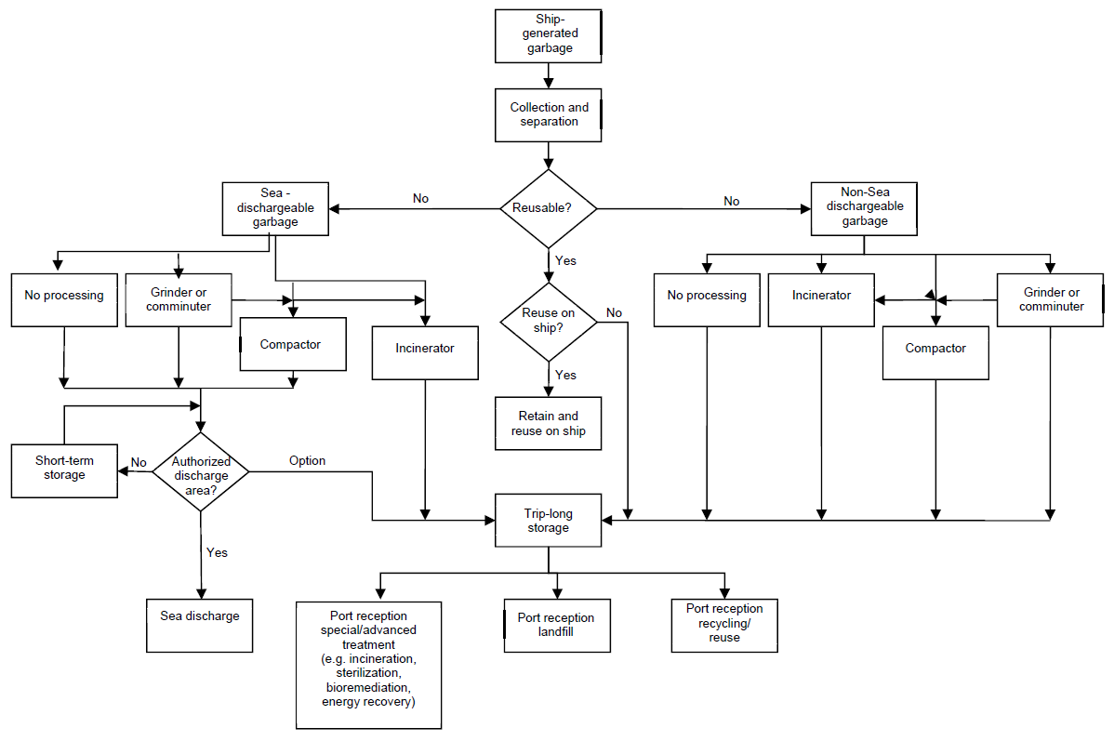



**APPENDIX 2**

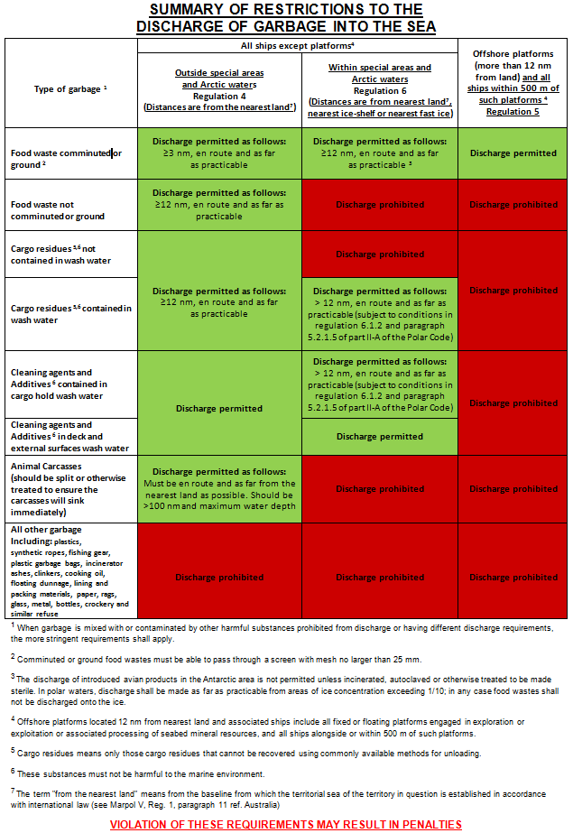

**APPENDIX 3**

**Sample placard targeting passengers**

***(in a language understood by them)***

